



ICT710

Interaction Design and Usability
Assignment 03
Design Report
Redesigning the Binance Mobile Trading App Using User-Centred Design
Based on the Needs Analysis and Usability Test Report (Assessment 2) by Udith Madushan Jayasinghe Jayasinghe Arachchige (ID 69191)
Student Name | Student ID
Udith Madushan Jayasinghe Jayasinghe Arachchige | 69191
Piyum Sugandha Kapurubandara Arachchige Don | 68750
Venkata Krishna Sai Yechuri | 66833
Pranay Kandela | 65924
Naveen Nallavelli | 65748

Table of Contents
Table of Figures 3
01. Introduction 4
1.1 Project Context 4
1.2 Target Users 4
1.3 Design Goals 4
02. Design Process 5
2.1 Methodology 5
2.2 Analyzing the existing design 5
2.3 From findings to requirements 7
2.4 Ideation and Iteration 7
2.5 Collaboration 9
03. Design Rationale 9
04. User Interface Design 11
4.1 Home, transfer and help 11
4.2 Buy flow 12
4.3 Sell flow 13
05. Usability Evaluation 13
5.1 Evaluation approach 13
5.2 Cognitive walkthrough and heuristic evaluation 14
5.3 Accessibility audit 14
5.4 Validation usability test 15
5.5 Recommendations and limit 16
06. AI-Assisted Design Evidence 16
07. Group Contribution Evidence 16
08. Conclusion 16
References 16
Appendices 18
Appendix A - Requirements traceability matrix 18
Appendix B - Validation test record sheet 19
Appendix C - Links 19

Table of Figures
Figure 1: Existing Binance UI 6
Figure 2: Iteration 1 low-fidelity wireframes 8
Figure 3: Redesigned home screen, bank transfer screen and Binance AI help screen 11
Figure 4: Redesigned Buy flow 12
Figure 5: Redesigned Sell Flow 13

Introduction

Project Context
Binance is a mobile trading app that comprises asset search, P2P trading, bank transfer and AI chatbot features. In Assessment 2, five participants completed five tasks using the app: searching, simulated purchasing, simulated selling, bank transfer and chatbot interaction [1]. All 25 tasks were completed successfully, although effectiveness was overshadowing inefficiency and dissatisfaction. The purchasing and selling tasks took, respectively, 69.4 s and 72.0 s, had 11 and 8 errors, required assistance from 60% of participants, and were scored 3.0/5 for ease of use. On the other hand, the chatbot took 10.4 s, did not require any assistance and received 4.6/5 points. Moreover, participants perceived the home page as having “too many things to look at”.
This report is in response to those results. The group based its design on the report by Udith Madushan Jayasinghe Jayasinghe Arachchige (ID 69191) in Assessment 2 and developed, justified and evaluated concept design for the home page, buying and selling flows, bank transfer page and help entry point. This is a coursework concept, not associated with Binance, and all numbers presented in the screens are purely illustrative.

Target Users
According to Assessment 2 survey, all the participants have previously used trading applications and mobile banking, and 80% of the participants have searched assets using a mobile phone but 60% of the participants do not use smartphone applications often or do not feel comfortable trying new apps and they are the most unfamiliar with transaction activities [1]. The proposed user group is digital-literate adults who are new and occasional traders.

Design Goals
Usability consists of three factors: effectiveness, efficiency, and satisfaction [2]. Since Assessment 2 demonstrated that the level of effectiveness was 100%, the focus will be on efficiency and satisfaction, with Assessment 2 being the benchmark.
Task | Time (A2 → target) | Errors, 5 users | Assistance | Ease (1–5)
Simulated purchase | 69.4 s → ≤ 45 s | 11 → ≤ 5 | 60% → ≤ 20% | 3.0 → ≥ 4.0
Simulated sale | 72.0 s → ≤ 45 s | 8 → ≤ 4 | 60% → ≤ 20% | 3.0 → ≥ 4.0
Bank transfer | 45.4 s → ≤ 30 s | 4 → ≤ 2 | 20% → 0% | 3.8 → ≥ 4.2
Search | 12.4 s → ≤ 10 s | 4 → ≤ 2 | 20% → 0% | 4.2 → ≥ 4.2
Chatbot | 10.4 s → maintain | 2 → ≤ 2 | 0% → 0% | 4.6 → ≥ 4.6
Table 1:Design Goals
Objectives are the group goals, and they should be challenging yet realistic, bearing in mind the achievement of 10.4 seconds by the chatbot, a guided purpose-built screen. The qualitative objectives are such that all screens will clearly show the next step, all users will know where they are in a multiple-step process, all users can preview before completing an action, and all screens will adhere to WCAG 2.2 Level AA [3].

Design Process

2.1 Methodology
Our design process followed the HCD approach defined in ISO 9241-210 [4], whereby one identifies the context of use, defines the requirements, produces the design solution and evaluates it based on the requirements. Assessment 2 covered the first two steps and the evaluation of the current product while this report covers design and re-evaluation. This approach was selected due to its explicit iterative nature, linking every design modification to evidence from users.

2.2 Analyzing the existing design
Before the design process started, we reviewed the Assessment 2 screenshots (Figure 1). Three structural issues caused the problem in the data. The first is that the Buy and Sell screens contain amount, method of payment, an offer to subscribe and the information about the counterparty on one screen, which makes the interface cognitively overloaded [5] and does not show the starting point. The second issue is that on the Sell screen, the information about the requirements of the counterparty appears as a long text without formatting, which forces users to read and filter to do something. Third, on the home screen, the user sees the balance, onboarding, big call-to-action, grid of shortcuts and scrolling tab bar all at once. The chatbot performed the best because it had one purpose, short suggested questions and one input.
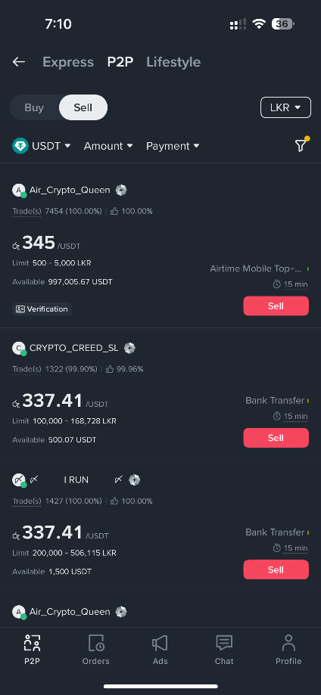
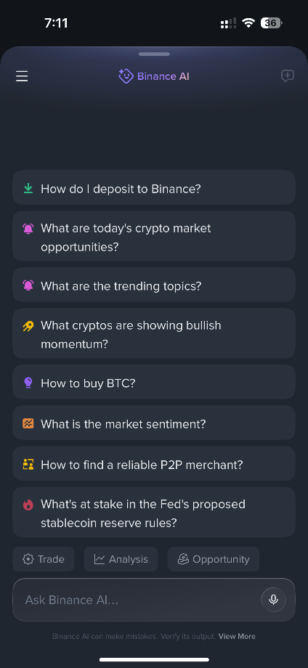
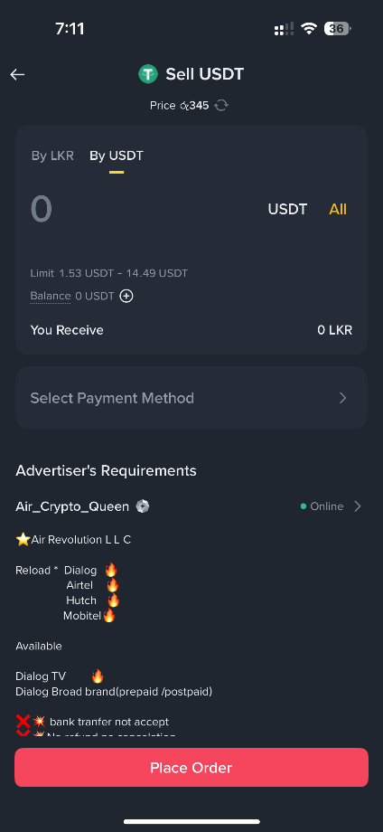
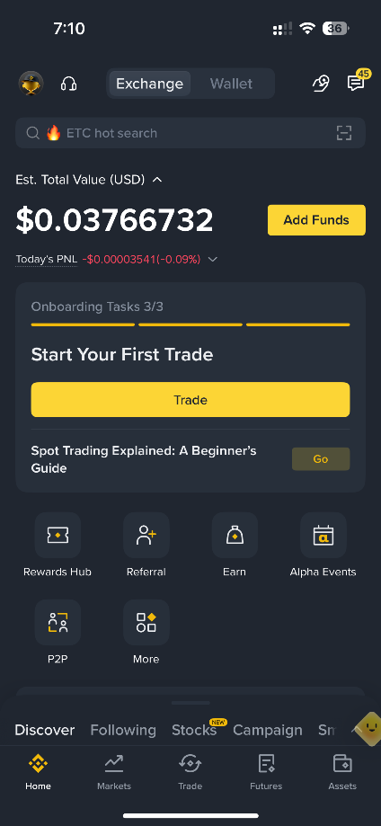
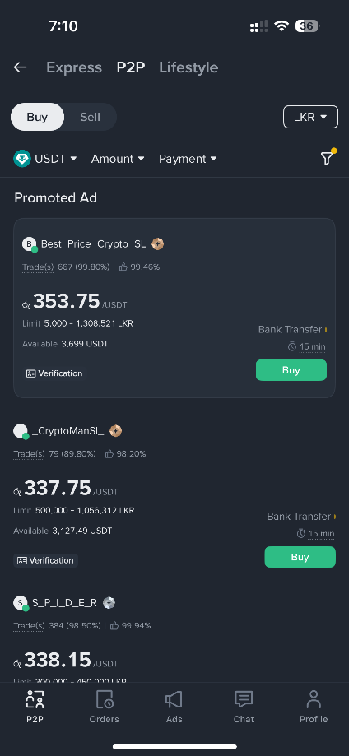
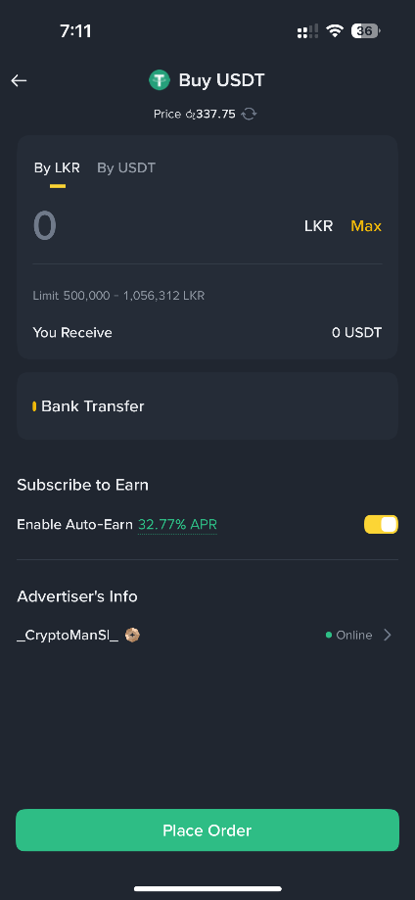

Figure 1: Existing Binance UI

2.3 From findings to requirements
All findings were turned into requirements and ranked based on the High/Medium ratings determined from Assessment 2. The full matrix, including decisions, principles, and WCAG criteria, is presented in Appendix A.
ID | Assessment 2 evidence | Requirement | Priority
R1 | Purchase: 69.4 s, 11 errors; “Where do I start?” | Obvious, labelled entry point to Buy. | High
R2 | “Seems like too many steps.” | Three short steps with a progress indicator. | High
R3 | Users need confirmation of each step. | Review-and-confirm screen before commitment. | High
R4 | Sale: 72.0 s, 8 errors; “How do I sell?” | Obvious Sell entry and predictable sequence. | High
R5 | “I don’t think I can complete this.” | Sell mirrors Buy for consistency. | High
R6 | Long counterparty requirements. | Summarise key rules; link to full terms. | High
R7 | Home “a bit too much”, “too many things to look at”. | Home limited to search, balance, four actions, short watchlist. | Medium
R8 | Secondary features compete with primary tasks. | Progressive disclosure under “More”. | Medium
R9 | Chatbot hard to find at first. | Labelled “Ask AI” action and help icon on every screen. | Medium
R10 | Chatbot fastest, 4.6/5. | Keep guided quick-question chips; add buy, sell, transfer. | Medium
R11 | Bank transfer: 45.4 s, 20% assistance. | Own labelled action; copyable details screen. | Medium
R12 | Less familiar with financial operations. | Plain-language labels, units and helper text. | High
R13 | A2 accessibility recommendations. | AA contrast, 44 px targets, no colour-only meaning. | High
R14 | Consistency across screens. | Single design system and shared components. | Medium

2.4 Ideation and Iteration
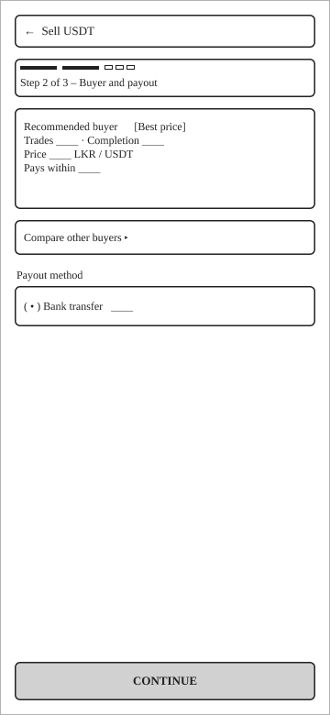
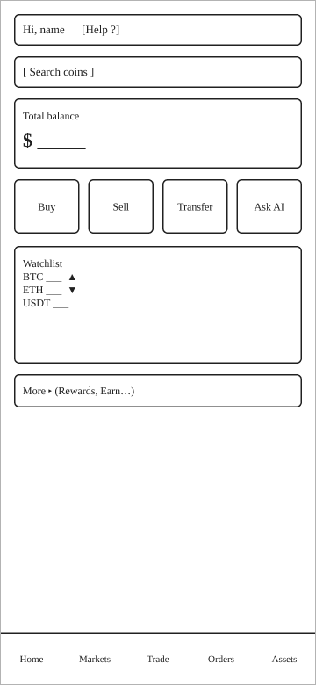
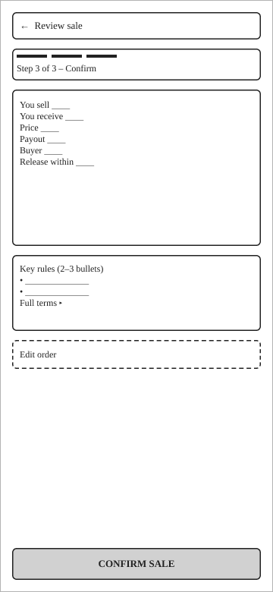
Design was done in three iterations (Table 2.4). For the first iteration, low-fidelity wireframes (Figure 2) were done first to decide on structure before deciding on visuals, so that the debate is about the flow, not the look [6]. The important decisions include same three steps for Buy and Sell, home screen as search > balance > actions > watchlist > “More,” and the presence of a help icon in every header. The second iteration yielded the high-fidelity screens with the dark theme shown in Section 4 as well as the Figma prototype, the dark theme was retained since the user already knows it and it reduces the relearning cost.
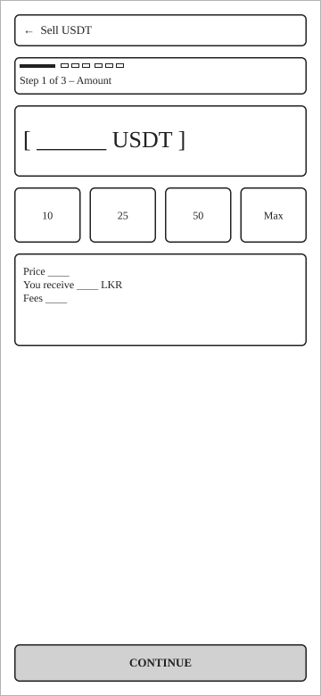
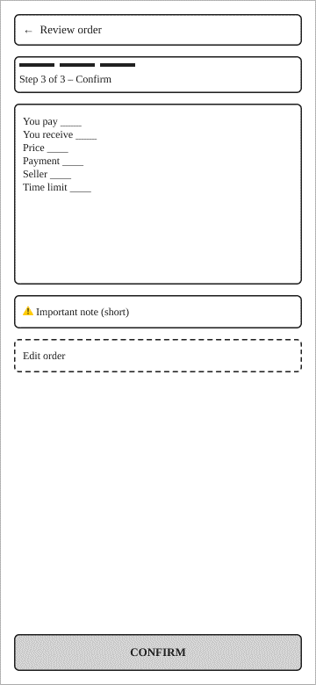
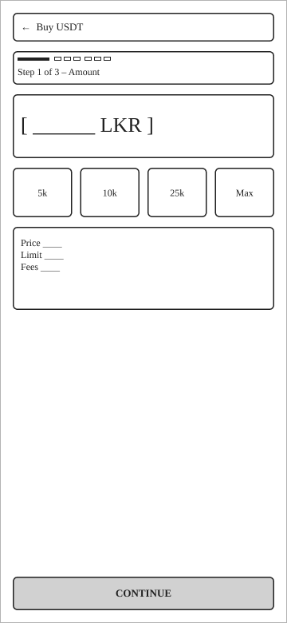
Figure 2: Iteration 1 low-fidelity wireframes
Version | Change | Reason | Evidence
v1 | Wireframes with three-step Buy/Sell and simplified home. | Settle structure; address R1 - R8. | Figure 2
v2 | High-fidelity screens, design system, Transfer screen, chat quick-question chips. | Hierarchy, consistency, R9 - R14. | Figures 3 -5
v3 | Contrast audit showed negative value red (#F6465D) at 4.48:1 on card surfaces, below the 4.5:1 AA minimum; text and the Sell icon changed to #FF6B7D (5.76:1). | WCAG 2.2 SC 1.4.3 [10]. | Table 5.3
Table 2: Iterations

2.5 Collaboration
For source code control of the document and design exports, the team utilized GitHub; for communication purposes, they used a messaging platform (Teams/WhatsApp); Figma was used to design and prototype and Word for assembling everything together. All the members had their own branches and made pull requests for changes approved by other members; work was done using GitHub Issues. Decisions were taken and documented in the meetings.
Prototype: Binance Redesign
Repository: https://github.com/udith97/ict710-a3-binance-redesign.git

Design Rationale
All decisions made below have three types of evidence supporting them the findings from Assessment 2, Human-Computer Interaction principles, and accessibility requirements. The principles include Nielsen’s heuristics [7], affordance, feedback, and mental models principles by Norman [8], progressive disclosure and proximity principles as summarised by Lidwell et al. [9], and limitations of working memory and cognitive load [10].
Decision | Evidence | Principle | Accessibility (WCAG 2.2 [3])
Three-step Buy flow with progress bar and “Step n of 3” (R2) | Purchase 69.4 s, 11 errors, 60% assistance, 3.0/5. | Fewer simultaneous choices lower decision time and cognitive load [9], [5]; visibility of system status [7]. | SC 2.4.6; step shown in text, not colour (1.4.1).
Review-and-confirm screen (R3) | Users need confirmation of each step. | Error prevention; user control (“Edit”) [7]. | SC 3.3.4 Error Prevention (financial).
Sell mirrors Buy (R5) | Sale 72.0 s; “I don’t think I can complete this.” | Consistency and standards [7]; transfer of learning [8]. | SC 3.2.3, 3.2.4.
Four large labelled actions on home (R1, R4, R9, R11) | No clear starting point; chatbot hard to find. | Recognition over recall [7]; large targets speed selection [9]; proximity grouping. | SC 2.5.8 target size; icon plus text label (2.4.6).
Simplified home with “More” (R7, R8) | “Too many things to look at.” | Aesthetic and minimalist design [7]; progressive disclosure [9]. | SC 1.3.1 logical order.
Recommended seller, others behind “Compare” (R2, R6) | Dense counterparty lists. | A default reduces choice effort while preserving control [9]. | Tag is text plus border (1.4.1).
Key rules summarised in bullets (R6) | Long unformatted requirements. | Help users recognise and understand [7] chunking within working-memory limits [10]. | SC 3.3.2 instructions.
Plain labels (“I want to spend”), units, helper text (R12) | Unfamiliar financial operations. | Match with the real world [7]. | SC 3.3.2; 1.4.4 resize text.
Help icon on every screen, quick-question chips (R9, R10) | Chatbot 4.6/5 but hard to find. | Help and documentation [7]. | SC 3.2.6 Consistent Help.
Copy buttons and reference on Transfer (R11) | Bank transfer 45.4 s, 20% assistance. | Minimise memory load; error prevention [7]. | SC 3.3.7 Redundant Entry.
Table 3: Design Decisions
Visual design: The dark color scheme has been retained, and yellow has been used for the sole primary action item on each screen so that users are immediately aware of what to do next. Grouping has been done via adjacency and important numbers are displayed as the largest and most prominent text. Purchase and Sale actions have used color in combination with a textual label such as “Confirm purchase” and “Confirm sale.” Gain/Loss values have used ▲/▼ symbols as per SC 1.4.1.
Compromises: While a one-page form may have less tapping, it has the same density as that which caused the mistakes in Assessment 2 while having five or more steps decreases the load per page, it will be hard to achieve the time goal of ≤ 45 seconds, hence, three steps were selected. A floating chat icon is always visible, but it might block the content or the main button, so it was decided to use a header icon for assistance [3].

User Interface Design
The following section provides the final high fidelity screens (v3). The navigation system still consists of five bottom tabs that have labels. Each task screen has a back button on the left side and a help button on the right side; all other functions are hidden under "More".

4.1 Home, transfer and help
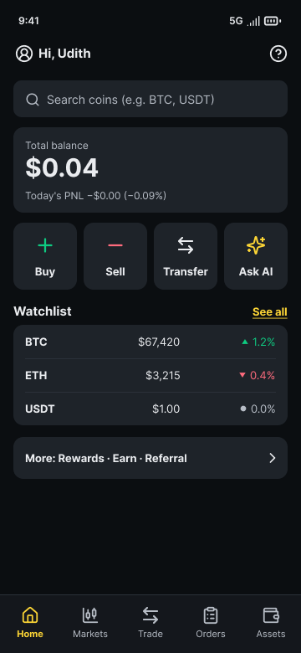
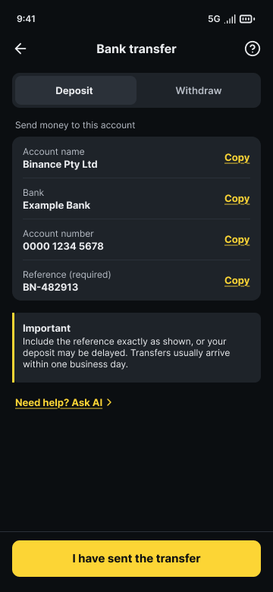
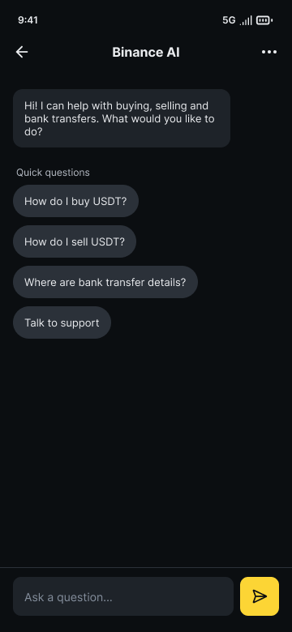
Figure 3: Redesigned home screen, bank transfer screen and Binance AI help screen
Order in Home is organized based on task importance searching, balancing, four major tasks (Buy, Sell, Transfer, Ask AI) and a watchlist with three rows Rewards, Earn and Referral are grouped into “More” (R1, R4, R7-R9, R11). Transfer contains tabs for Deposit/Withdraw, four fields which can be copied, mandatory reference and plain language disclaimer followed by “I have sent the transfer” button (R11, R12). Help section maintains quick question format from the previous design with 4.6/5 rating along with chips about buying/selling/bank transfer information (R9, R10).

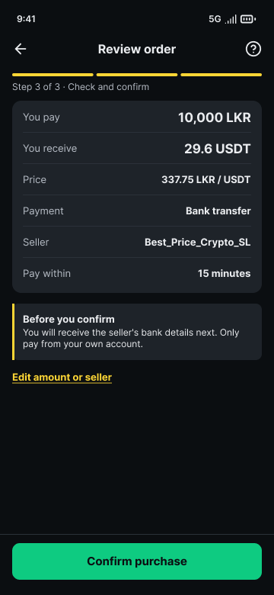
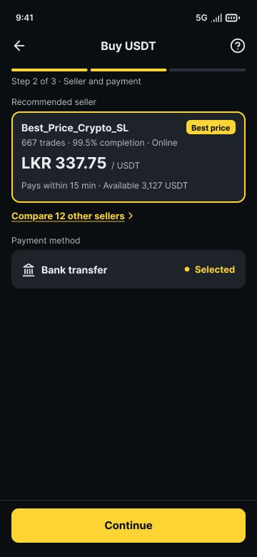
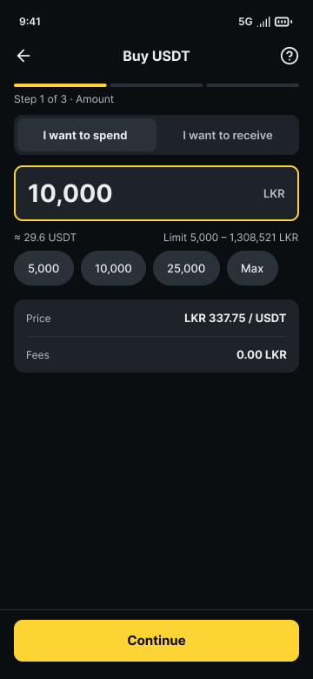
4.2 Buy flow

Figure 4: Redesigned Buy flow
In Step 1, there is a big input along with live conversion, quick amount chips, and price and limit summary. In Step 2, there is a recommendation of one seller along with the number of trades, completion rate, and best price tag. It maintains optional comparison and shows payment in the form of a single selectable card. In Step 3, all figures are shown at one place and it tells what will happen next with an edit option.

4.3 Sell flow
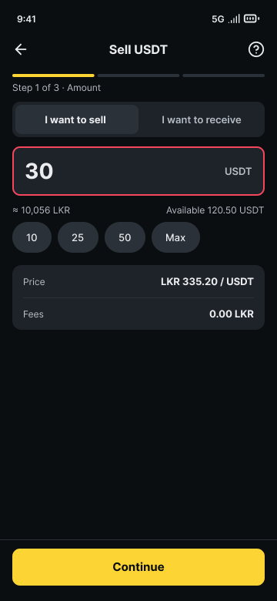
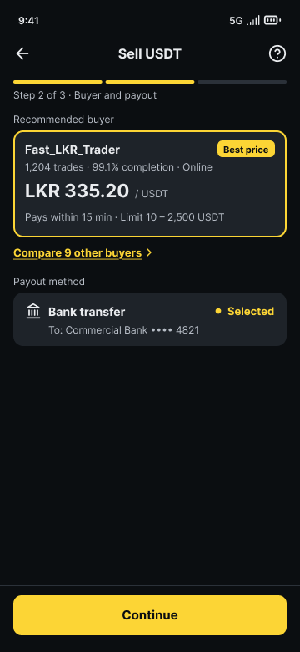
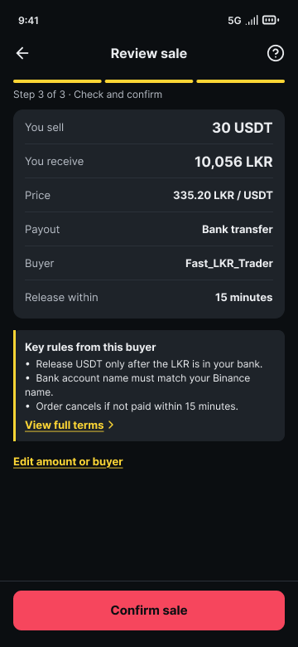
Figure 5: Redesigned Sell Flow
Sell follows the pattern of the header, progress bar, and button placement as that of Buy, but the accent color for the amount and the last button is red (“Confirm sale”; R5). The lengthy conditions of the counterparty are condensed to the two/three conditions impacting the decision, with a hyperlink to the full conditions (R6).

Usability Evaluation

5.1 Evaluation approach
The analysis was done in a combination of three techniques that were later followed by a user test. A cognitive walkthrough of all five tasks from Assessment 2 [1] determined whether the users could discover and comprehend each action a heuristic analysis according to Nielsen’s heuristics [7] was done to see what other issues may still remain and a contrast audit applied the WCAG relative-luminance formula [3]. The analytical techniques can be conducted prior to getting any users and finding most of the bugs inexpensively, yet they cannot check efficiency and satisfaction.

5.2 Cognitive walkthrough and heuristic evaluation
Task | Action sequence on the prototype | Primary taps | Requirements
Search | Home > Search > type > choose result | 2 + typing | R7
Buy | Home > Buy > amount > Continue > Continue > Confirm purchase | 4 + amount | R1 - R3, R12
Sell | Home > Sell > amount > Continue > Continue > Confirm sale | 4 + amount | R4 -R6
Bank transfer | Home > Transfer > read/copy details > I have sent the transfer | 2 + copies | R11
Chatbot | Home > Ask AI > quick question | 2 | R9, R10
Table 4: Cognitive walkthrough
At every stage we checked whether the user would attempt the correct action, recognize it, associate it with their goal, and see that they were making progress. Each stage features one obvious bottom action, a progress bar labeled for the user's goal and an instant feedback result displayed on screen. There was not a stage at which the next action was ambiguous.
Severity scale: 0 none, 1 cosmetic, 2 minor, 3 major, 4 catastrophic.
Heuristic [7] | Redesign / remaining issue | Sev. | Action
1 Visibility of status | Progress bar, live conversion; no loading/submitted state. | 1 | Design submitted state with order number.
2 Real-world match | Plain labels; “P2P” and “Limit” may still be unfamiliar. | 1 | Test wording with new users.
3 User control | Back arrow and Edit link; no cancel confirmation. | 1 | Add cancel-order confirmation.
4 Consistency | Buy and Sell share structure. | 0 | Maintain components.
5 Error prevention | Review screen; limits shown; no inline validation. | 2 | Design out-of-limit and low-balance messages.
6 Recognition | Chips, default seller, copy buttons. | 0 | –
7 Flexibility | Quick amounts help; no expert shortcut. | 2 | Add “Repeat last order”.
8 Minimalism | Home reduced; “More” may hide expected items. | 1 | Verify in test.
9 Error recovery | Error states not designed. | 2 | Write plain-language error messages (SC 3.3.1, 3.3.3).
10 Help | Help icon and AI chips; no inline help for fees. | 1 | Add contextual “What is this?”.
Table 5: Heuristic evaluation

5.3 Accessibility audit
In terms of WCAG 2.2 SC 1.4.3, the minimum contrast ratio for text is 4.5:1 [3]. Contrast ratios were computed using the color values.
Combination | Colours | Ratio | AA result
Primary text / background | #EAECEF on #0B0E11 | 16.35 : 1 | Pass
Primary text / card | #EAECEF on #1E2329 | 13.36 : 1 | Pass
Secondary text / card | #B7BDC6 on #1E2329 | 8.37 : 1 | Pass
Button text on yellow | #0B0E11 on #FCD535 | 13.55 : 1 | Pass
Button text on green | #06231A on #0ECB81 | 7.82 : 1 | Pass
Button text on red | #2B0509 on #F6465D | 5.28 : 1 | Pass
Gain text / card | #0ECB81 on #1E2329 | 7.44 : 1 | Pass
Loss text / card - v2 | #F6465D on #1E2329 | 4.48 : 1 | Fail
Loss text / card - v3 | #FF6B7D on #1E2329 | 5.76 : 1 | Pass

There was indeed one actual problem, fixed in v3. The reason we measured it rather than relying on our perception was that the color appeared very clear but may have been just below the threshold value.

5.4 Validation usability test
The five Assessment 2 tasks will be repeated using the Figma prototype, with the same criteria for assessment (completeness, time taken, errors, help sought, easiness 1-5), and the same participants (V1-V5. Five participants will suffice to detect most issues in the formative usability test [11]. Each task will have a maximum of 120 s, participants provide their informed consent and there will be no actual transactions. Participants will then fill out the System Usability Scale (SUS) [12] an average score of 68 is usually cited [13], therefore our minimum acceptable result is set at ≥ 68.
Task | A2 time - target | Time (s) | Errors | Assistance | Ease (1–5)
Search | 12.4 s - ≤ 10.0 s | 3.2 | 0 | 0% | 5.0
Buy | 69.4 s - ≤ 45.0 s | 29.6 | 5 | 40% | 4.6
Sell | 72.0 s - ≤ 45.0 s | 29.0 | 6 | 20% | 4.8
Bank transfer | 45.4 s - ≤ 30.0 s | 22.2 | 2 | 20% | 4.8
Chatbot | 10.4 s - ≤ 10.4 s | 6.0 | 2 | 0% | 4.6
Table 6: Validation results against the baseline and targets

5.5 Recommendations and limit

No | Recommendation | Evidence | Priority
1 | Design and test error, loading and submitted states for Buy and Sell. | Heuristics 1, 5, 9. | High
2 | Iterate to v4 on any task that misses its target. | Section 1.3 targets. | High
3 | Add a “Repeat last order” shortcut for experienced users. | Heuristic 7. | Medium
4 | Add contextual help for fees, limits and P2P terms. | Heuristics 2, 10. | Medium
5 | Offer a light theme; test 200% text size and a screen reader. | SC 1.4.4. | Medium

Limitations: Walkthrough and Heuristic Evaluation was performed by the design team who already knows the proposed design and thus is likely to overlook certain issues faced by the actual users. The same participants from Assessment 2 have been used for the validation test and hence two implications follow. First, their previous experience with the task and app might have led to quicker completion of the task due to practice effects rather than any redesign, hence improvements in performance must be interpreted carefully using mainly user comments. Second, their prior knowledge of the aim of the study may have created a positive bias about the redesign. Nevertheless, using the same participants allows within-subjects comparison since the difference between people in terms of speed and confidence is constant in both conditions. Five participants do not constitute a statistically representative sample [11], there are only five illustrative screen groups, and no actual transactions were completed.

AI-Assisted Design Evidence
# | Stage | Prompt (summary) | AI output | Decision | Evaluation and validation
1 | Initial
2 | Refinement
3 | Refinement

Group Contribution Evidence

Conclusion

References

[1] | U. M. Jayasinghe, "Assesment 2 - Needs Analysis and Usability Test Report (ICT710)," Victorian Institute of Technology, 2026.
[2] | Internation Organization of Standardization, "ISO 9241-11:2018 Ergonomics of human-system interaction Part 11: Usability: Definitions and concepts," 2018. [Online]. Available: https://www.iso.org/standard/63500.html. [Accessed 10 10 2026].
[3] | World Wide Web Consortium, "Web Content Accessibility Guidelines (WCAG) 2.2," 12 12 2024. [Online]. Available: https://www.w3.org/TR/WCAG22/. [Accessed 12 10 2026].
[4] | International Organization for Standardization, "ISO 9241-210:2019 Ergonomics of human-system interaction Part 210: Human-centred design for interactive systems," 2019. [Online]. Available: https://www.iso.org/standard/77520.html. [Accessed 10 10 2026].
[5] | J. Sweller, P. Ayres and S. Kalyuga, Cognitive Load Theory, 2011.
[6] | Y. Rogers, H. Sharp and J. Preece, Interaction Design: Beyond Human-Computer Interaction, NJ, USA: Hoboken, 2019.
[7] | J. Nielsen, "10 Usability Heuristics for User Interface Design," NNGroup, 30 01 2024. [Online]. Available: https://www.nngroup.com/articles/ten-usability-heuristics/. [Accessed 10 10 2026].
[8] | D. A. Norman, The Design of Everyday Things, New York: Basic Books, 2013.
[9] | W. Lidwell, K. Holden and J. Butler, Universal Principles of Design, Beverly, MA, USA, 2010.
[10] | N. Cowan, "The Magical Mystery Four: How is Working Memory Capacity Limited, and Why?," Current Directions in Psychological Science, vol. 19, pp. 51-57, 2010.
[11] | J. Nielsen, "How Many Test Users in a Usability Study?," 03 June 2012. [Online]. Available: https://www.nngroup.com/articles/how-many-test-users/. [Accessed 21 September 2026].
[12] | J. R. Lewis, "The System Usability Scale: Past, Present, and Future," International Journal of Human-Computer Interaction, vol. 34, no. 7, pp. 577-590, 2018.
[13] | J. R. Lewis and J. Sauro, Excel and R Companion to the Second Edition of, Cambridge, MA, USA: Morgan Kaufmann, 2016.

Appendices

Appendix A - Requirements traceability matrix
A2 finding | Req. | Design decision (screen) | Principle | WCAG 2.2 | Checked in
Purchase 69.4 s; “Where do I start?” | R1 | Buy action on home (Fig. 3) | Recognition over recall; Fitts | 2.4.6, 2.5.8 | Walkthrough; Table 5.4
“Too many steps”; 11 errors | R2 | Three-step flow, progress bar (Fig. 4) | Hick; cognitive load | 1.4.1, 2.4.6 | Heuristic 1; Table 5.4
Users need confirmation | R3 | Review screen (Fig. 4) | Error prevention; control | 3.3.4 | Heuristics 3, 5
Sale 72.0 s; “How do I sell?” | R4 | Sell action on home (Fig. 3) | Recognition; Fitts | 2.4.6, 2.5.8 | Walkthrough; Table 5.4
“Can’t complete this” | R5 | Sell mirrors Buy (Fig. 5) | Consistency | 3.2.3, 3.2.4 | Heuristic 4
Long requirements text | R6 | Summarised rules; link to terms (Fig. 5) | Chunking; recognition | 3.3.2 | Heuristic 2; Table 5.4
Home “too much” | R7 | Simplified home (Fig. 3) | Minimalist design | 1.3.1 | Heuristic 8
Secondary features compete | R8 | “More” group (Fig. 3) | Progressive disclosure | 1.3.1 | Heuristic 8
Chatbot hard to find | R9 | Ask AI action; help icon (Figs 3-5) | Help and documentation | 3.2.6 | Heuristic 10
Chatbot 4.6/5 | R10 | Quick-question chips (Fig. 3) | Recognition | 3.3.2 | Table 5.4 (chatbot)
Bank transfer 45.4 s | R11 | Transfer screen, copy buttons (Fig. 3) | Memory load; error prevention | 3.3.7 | Table 5.4 (transfer)
Unfamiliar with finance | R12 | Plain labels, units, helper text (Figs 3 -5) | Real-world match | 3.3.2, 1.4.4 | Heuristic 2
A2 accessibility list | R13 | Contrast, targets, labels (Section 4.4) | Redundant coding | 1.4.1, 1.4.3, 2.5.8 | Table 5.3
Consistency across screens | R14 | Shared components (Section 4.4) | Consistency | 3.2.3, 3.2.4 | Heuristic 4

Appendix B - Validation test record sheet
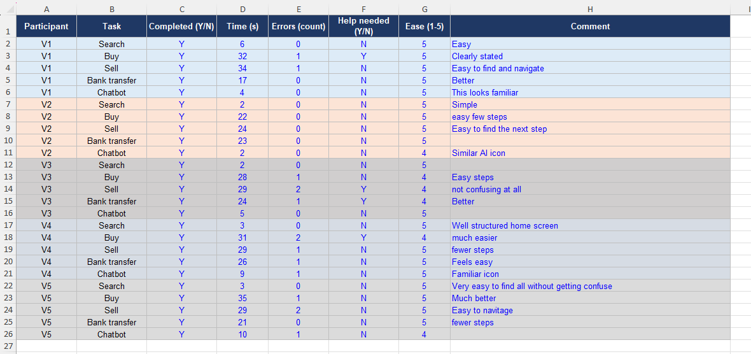
The actual file is available in the github repository under Userbility Test Report.

Appendix C - Links
Item | Link
Figma prototype | https://www.figma.com/proto/NHhBNpb9dW1QyG4OUtTl8s/ICT710-A3-%E2%80%93-Low-fi-Wireframes--Iteration-1-?node-id=3-3&p=f&t=ob0m4x0ppImNyLup-1&scaling=min-zoom&content-scaling=fixed&page-id=3%3A2&starting-point-node-id=3%3A3&show-proto-sidebar=1
GitHub repository | https://github.com/udith97/ict710-a3-binance-redesign.git
Assessment 2 report, questionnaire and record sheet | Assessment 2, Appendices 1–3 (Assessment 2 is under Source folder in GitHub repository)

